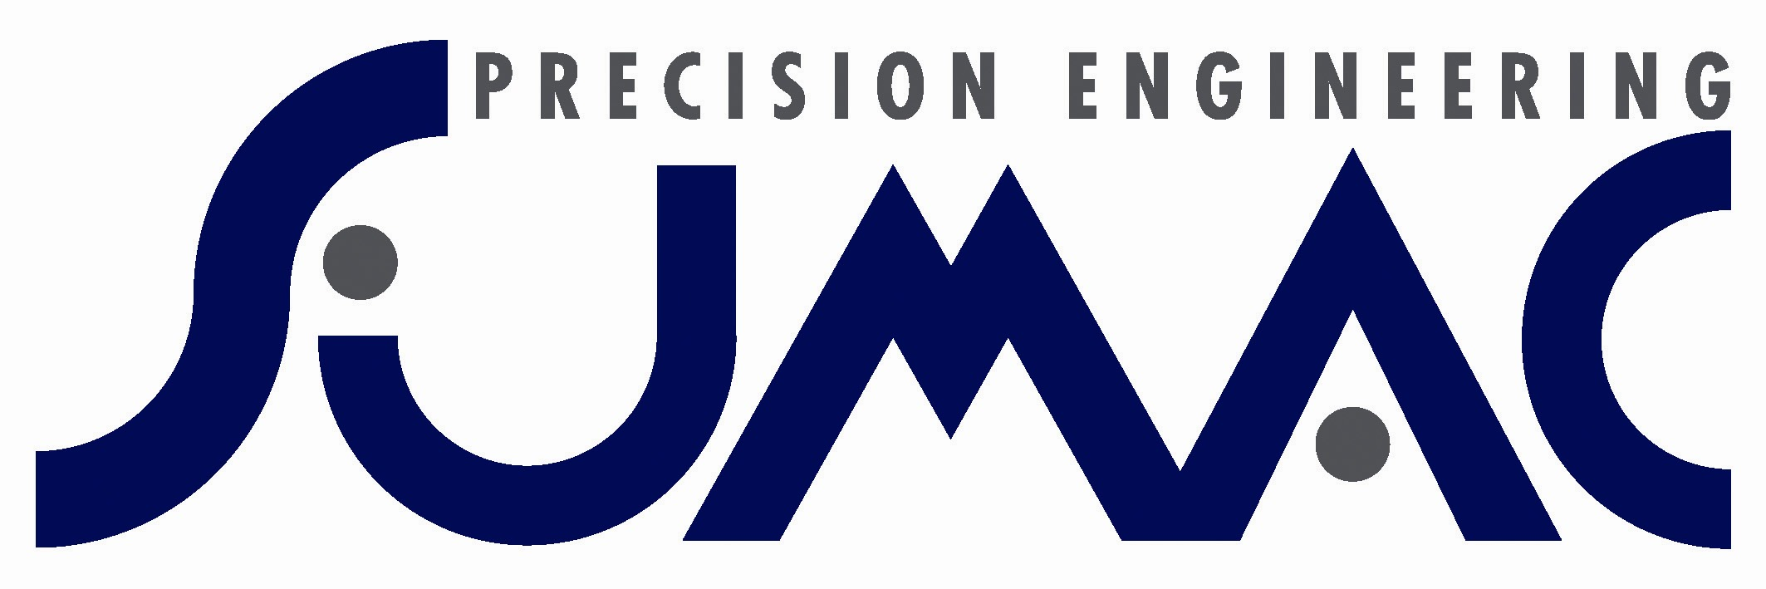

QUALITY MANUFACTURING SERVICE

CNC MILLING 3, 4 & 5 Axis Including Automation

YCM NFX400A 5 Axis Heidenhain 640 Control with 60 tool capacity, spindle and tool probing integrated with
Cellro Xcelerate X20 Robot work piece loading system.

Erowa Leonardo Pallet Loading across 2 machines
YCM NFX380A 5 Axis Heidenhain 640 Control with 60 tool capacity, spindle and tool probing
Capacity – 18 x Pallets of 225 x 225mm x 200mm high
YCM Fx350 5 Axis Heidenhain 530 Control with 60 tool capacity, spindle and tool probing
Capacity – 25 x Pallets of 148mm Ø x 200mm high

YCM Fx350AH x 2 off 5 Axis Heidenhain 530 Control using individual Erowa Compact work piece loading systems
Capacity - 50 Pallets of 148mm Ø x 200mm high.

HEDELIUS Tiltenta 7 5 axis CNC-control Heidenhain 530 control, moving column machining centre
continuous tilting main spindle. Capacity 4200mm x 750mm x 695mm

YCM Fx350AH 5 Axis (Heidenhain 530) x 4 Capacity 350mm Ø Trunnion
YCM TV188B 3 Axis (Heidenhain 530) Capacity 1800 x 860 mm
YCM TV158B 3 Axis (Heidenhain 530) Capacity 1600 x 860 mm
YCM NXV102A 3 Axis (Heidenhain 620) x 3 Capacity 1020 x 510mm
YCM MV106A 3 Axis (Heidenhain 530) Capacity 1060 x 510 mm
YCM MV168A 3 Axis (MXP200i Fanuc) Capacity 1650 x 750 mm
YCM FV125A 3 & 4 Axis (MXP200i Fanuc) Capacity 1250 x 510 mm (with 4th Axis)
YCM NSV66A 3 Axis (Heidenhain 530) Capacity 660 x 510 mm
YCM XV560AH 3 Axis (Heidenhain 530) x 5 Capacity 560 x 410 mm
Bridgeport VMC600/22 3 Axis (Heidenhain 410) Capacity 600 x 510 mm
Bridgeport VMC800/22 3 Axis (Heidenhain 410) Capacity 800 x 510 mm (with 4th Axis)
Bridgeport VMC800/22 3 Axis (Heidenhain 410) x 2 Capacity 800 x 510 mm

CNC TURNING 2 Axis to 9 Axis

Daewoo Puma MX2000ST 9 Axis -Fanuc 18iTB Control System: Two full ‘C’ Axis 22kW spindles, 15kW (10,000rpm) Milling Spindle, Full 240 deg ‘B’ axis & Full Size Lower Turret with 7.5kW Driven tools, with a 1.5 metre LNS Servo 2 Bar System. Work Envelope = 550mm dia x 1020 mm, with 65mm Bar Capacity.

Daewoo Puma MX2000SY 6 Axis -Fanuc 18iTB Control System: 15kW Main Spindle + 7.5kW Sub Spindle, 5.5kW Driven Tools with Hydrafeed Multifeed Bar System. Work Envelope 330mm dia x 510mm, with 65mm Bar Capacity

Miyano BND-42S Fanuc CNC Control C Axis Driven Tooling & Sub Spindle Hydrafeed 3-80 Magazine Barfeed
42mm Main Spindle Capacity plus 34mm Sub Spindle.

Ecoca SJ-20MC Fanuc CNC Control C Axis Driven Tool Turret Hydrafeed 3-80 Magazine Barfeed

Goodway GCL-2B Fanuc CNC Control 200mm Ø Capacity, 51mm Bar Capacity. Hydrafeed 3-80 Magazine Barfeed

Goodway GS-260 Fanuc CNC Control 400mm Ø Capacity, 51mm Bar Capacity. C-Axis Driven tool Turret.

Goodway Sliding Head SW32 Fanuc CNC 32mm Bar Capacity. Twin Spindle 3 Metre Barfeed

All CNC Machining fully supported by Mastercam, EdgeCam & Solidworks

(Computer Aided Engineering + Pro–E Capability).

WELDING AND SHEET METAL

Laser Cutting, Fabrication and Welding

Bystronic Bystar 3015 laser cutting machine Capacity 3000mm x 2000mm with a 4 axis
Amada press brake HFE 130-4 Capacity 130 tonne x 4.0 metres down stroke
RQH Pressbrake Capacity 30 tonne x 1.5 metres
Promecam Pressbrake Capacity 35 tonne x 2.4 metres
Edwards pearson press brake PR4 100/3100 Capacity 100 tonne x 3.0 metres
Edwards Guillotine Capacity Truecut 48” X 10g Mild Steel
Edwards Guillotine Capacity 3 Metre x 6mm Mild Steel
Hydranotch Femco Corner Notcher
Press & Shear Ltd 2 Meter Rollers
Press & Shear Ltd Strippit Super 30/30/30 Fabricator
Meritus Spot Welder Model 5002420
Ineco Basic Tube Bender Tube Scalloper
Migatronic Tig welding x 15 sets
Migatronic Mig Welding x 4 set
Transarc Welder Metal Arc 200 Amp

CONVENTIONAL MACHINE SHOP WITH FULL ANCILLARY & SUPPORTING PLANT

MANUAL MILLING MANUAL TURNING
(5x) SMX2 3000 SLV Turret Milling Machine 3 Axis. Cyclematic Toolroom Lathe CTL618e
Swift Toolroom Lathe Model 618
Colchester Centre Lathe Master 2500
Harrison Centre Lathe M450
Dalian Centre Lathe 6250/1500
XYZ Proturn Centre Lathe 425 X 2000

GRINDING & HONING
Okamoto Grinder 105DX 1.05 x 0.5m Table
J & S Surface Grinder 1400 24” x 6” Table
J & S EIU 1074 Universal Grinder 10” swing x 18” long
GP Centreless Grinder
Delapena Auto Speedhone machine

INSPECTION
Fully Equipped Inspection Facilities and Quality Control
Keyence IM Instant Measurement System
VDMIS based CNC Co-Ordinate Measuring Machine.
Manual Co-Ordinate Measuring Machine
Faro Arm 1.2M Ø with Delcam software

ASSEMBLY
Fully Equipped Dedicated Assembly Areas
Electro-Mechanical

ANCILLARY & SUPPORT PLANT
uMeta Laser Engraving Machine
Glass Bead & Grit Blasting
Electro Arc Spark Eroder
Line Grinding
Fully equipped material cutting and preparation.

